Naples Chapter Motherhood Support

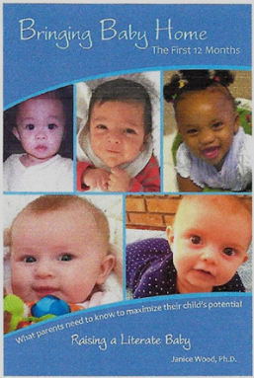Bringing Baby Home Program

**Timing, duration, frequency of program**

Books are ordered generally once a year to be distributed with layettes year round.

**Fiscal Information**

Budgeted expense total for program last year: $12,000

**Partnerships**

Work together with Layette Committee which adds book to the layettes and distributes to new mothers.

**Clients**

Number of children/families served your last fiscal year: 600

Age range of clients served: New mothers

**Volunteers**

How many volunteers participate in this program (planning and working) 1

What roles do the volunteers have in this program? Order the books in English, Spanish and Creole

**Program Description**

Overall goal of this program: to provide information to first time mothers

What service/materials do you provide to your clients? The book Bringing Baby Home - The First Twelve Months Raising a Literate Baby by Dr. Janice Wood, an early childhood education professor

The book was written to provide information in an easy-to-read format that helps equip parents and infant caregivers the knowledge they need to give their infants the very best during the first 12 months of life.

The first section of the book is designed to provide general information about the care of an infant. The second section of the book describes easy to do literacy activities that can be done during the first year of life. The author developed many literacy games and identifies many songs, poems, toys and books that parents and caregivers can use in meaningful, literacy-rich ways. The literacy activities that are described will help children develop fundamental communication skills

**Table of Contents include:**

First Days at Home Raising a Literate Baby Language Activities for Mom and Baby

Baby Basics Characteristics of the First Year Songs and Poems

Feeding Your Baby of Life Lap games for Mom and Baby

Keeping Baby Healthy Physical Development, Language Reading to Your Baby

Keeping Baby Safe Development Books and Toys for Your Baby

Quality Infant Care Social-Emotional Development

Contact: naples@ nationalchristchild.org