Naples Chapter Reading and Literacy

Habitat Books Program

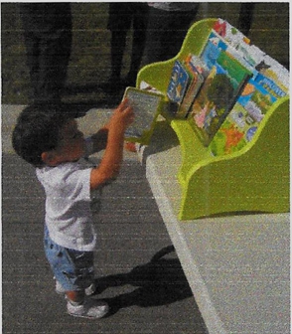

**Timing, duration, frequency of program**

Four times per year

**Fiscal Information**

Budgeted expense total for program last year: $3,000

**Partnerships**

Habitat for Humanity and Books for Collier Kids

What role does your partner(s) have in the program? Habitat works closely with CCS Naples to receive and organize the donated books. This project started many years ago and a third group made tabletop bookshelves on which the books sat when the homes were opened and blessed. Habitat took over the responsibility of making the shelves and created a group of volunteers to do so. Books for Collier Kids works in concert with CCS Naples to provide books for the Habitat bookshelves.

**Clients**

Number of children/families served your last fiscal year: 100 families; 160 – 200 children

Age range of clients served: birth to 18

**Volunteers**

How many volunteers participate in this program (planning and working) 15

What roles do the volunteers have in this program?

What roles do the volunteers have in this program? Volunteers preview titles; order books; unpack

books; label books; sort and package sets of books; deliver books to Habitat offices

**Program Description**

Overall goal of this program: To provide a set of books for families moving into their Habitat homes to read and reread addressing one of the most important factors affecting literacy - access to books

Christ Child Society Naples teamed up with Habitat for Humanity (starting in 2013), Books for Collier Kids and the Notre Dame Alumni Naples Chapter to create "starter libraries" for families moving into Habitat homes. This project continues under our regular budget. Volunteers preview and select a variety (fiction, non-fiction, age level, reading level. poetry. reference) books which are then ordered in coordination with Books for Collier Kids. Once delivered. the books are unpacked, labeled and sorted according to a schedule developed by the Chair of this committee in coordination with the Literacy Chair. Approximately 100 homes are opened as Habitat for Humanity homes in Collier County each year. Generally 25 sets of books are created during each of the four sorting sessions during the course of our fiscal year. Once created, a volunteer assumes responsibility for delivering the sets to the Habitat offices.

Contact: naples@nationalchristchild.org